Silhouette metric for img011001.jpg is: 0.9796540942392157

Davies Bouldin metric for img011001.jpg is: 0.02767522580879675

Calinski Harabasz metric for img011001.jpg is: 901332.8070951201

ID 0: (1736, 445)

ID 1: (1087, 177)

ID 2: (965, 291)

ID 3: (915, 413)

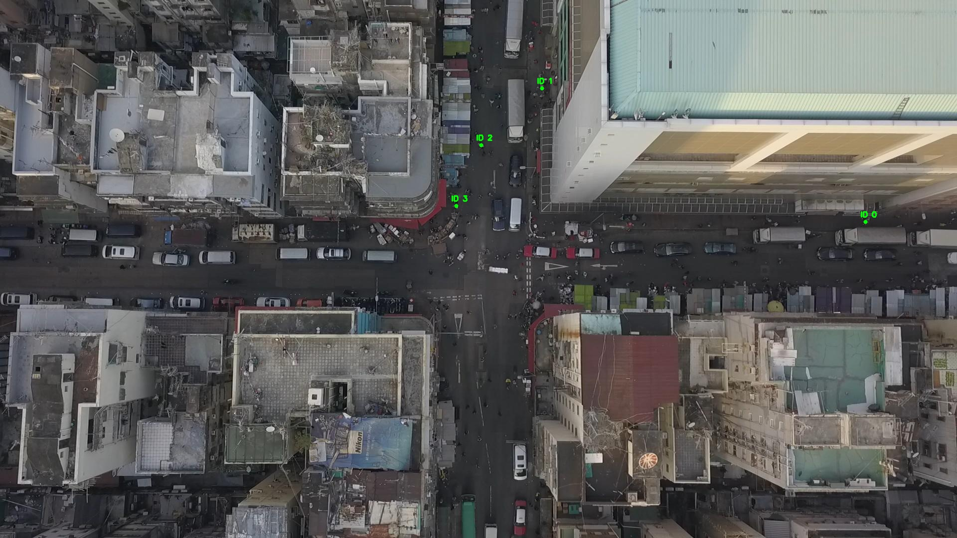

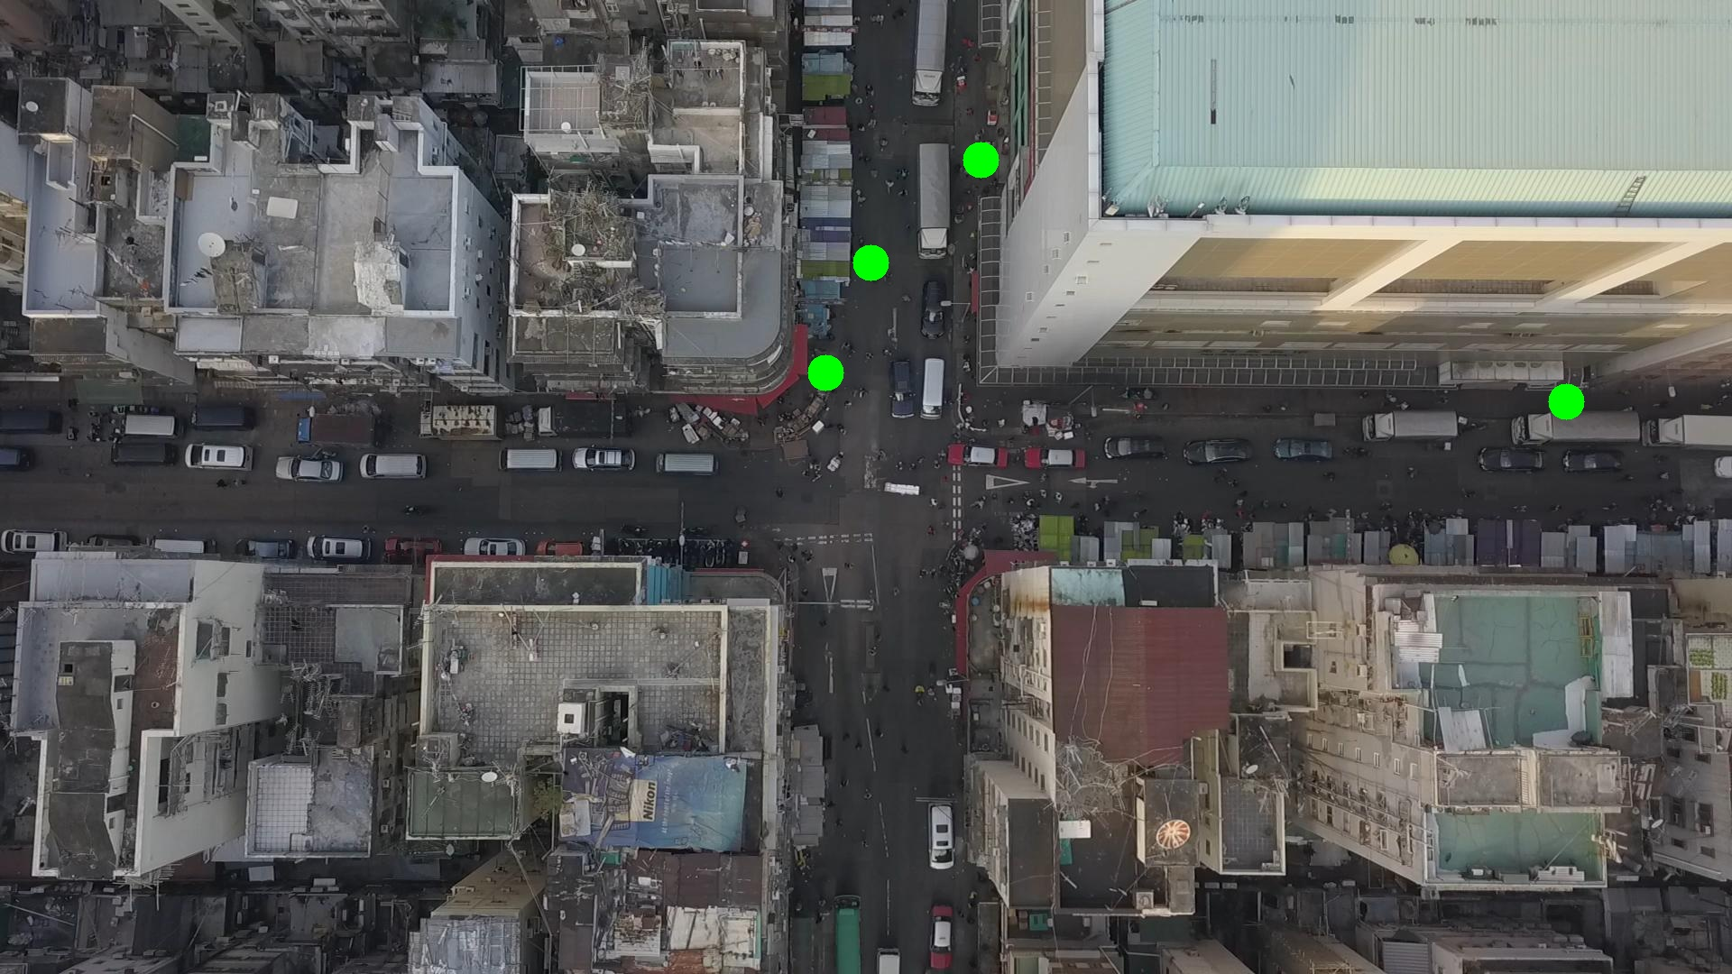

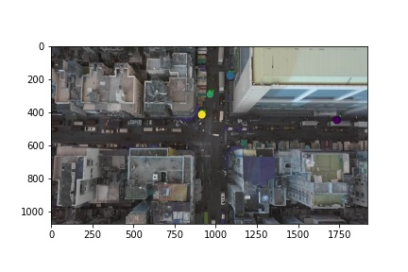

Silhouette metric for img011002.jpg is: 0.9013541217343254

Davies Bouldin metric for img011002.jpg is: 0.11943068229094016

Calinski Harabasz metric for img011002.jpg is: 8120.136763454029

ID 0: (1142, 557)

ID 1: (1087, 178)

ID 2: (997, 193)

ID 3: (889, 440)

ID 4: (937, 815)

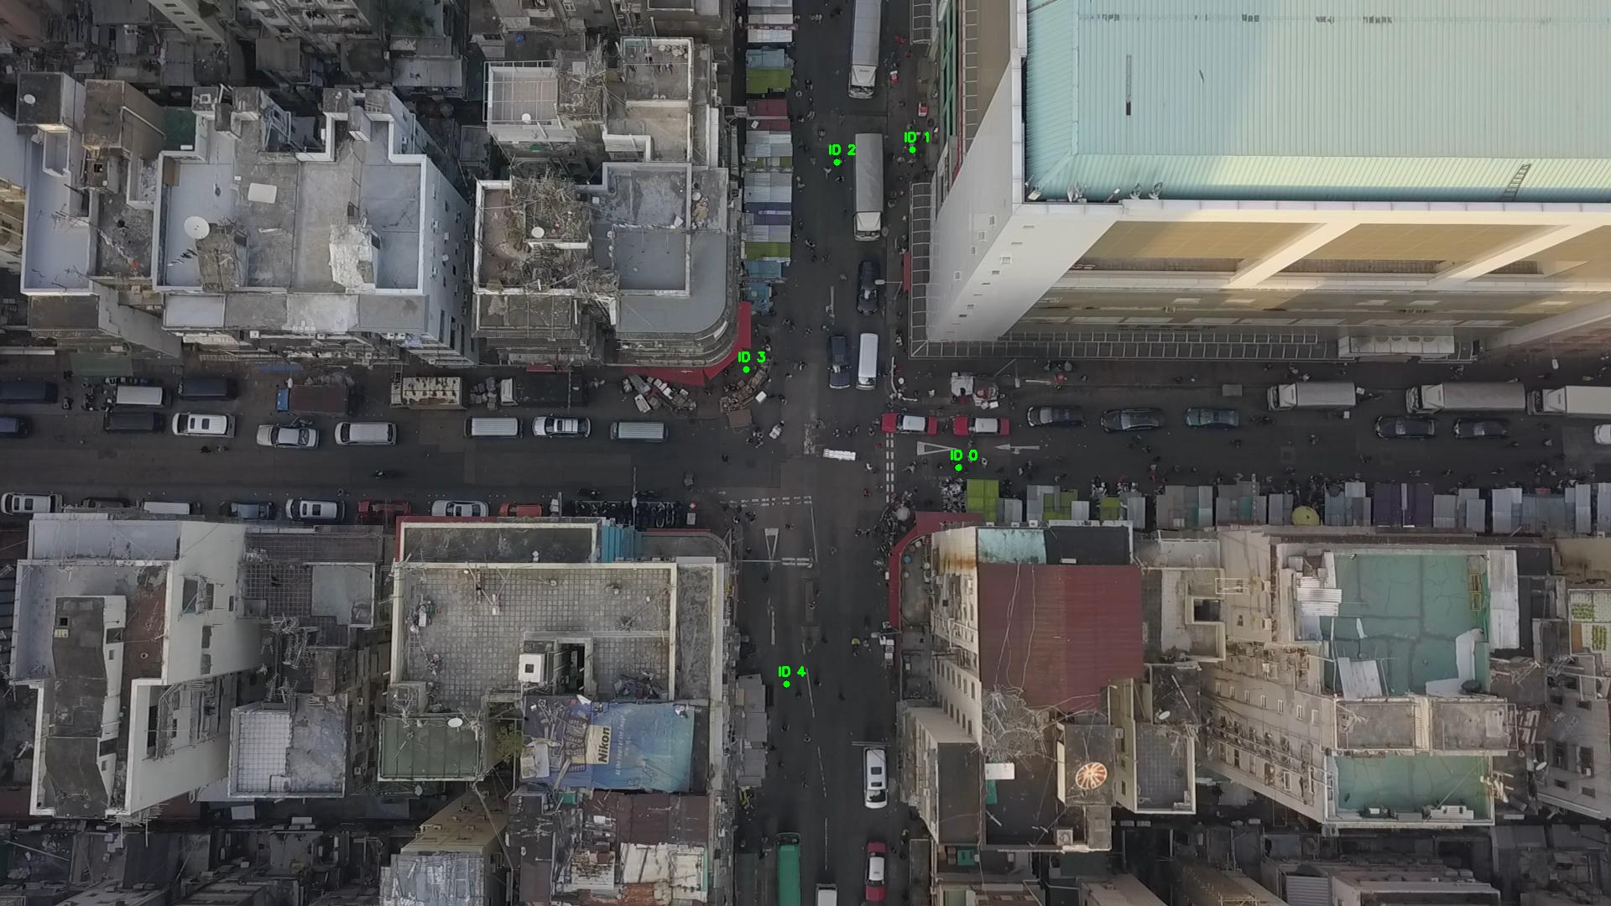

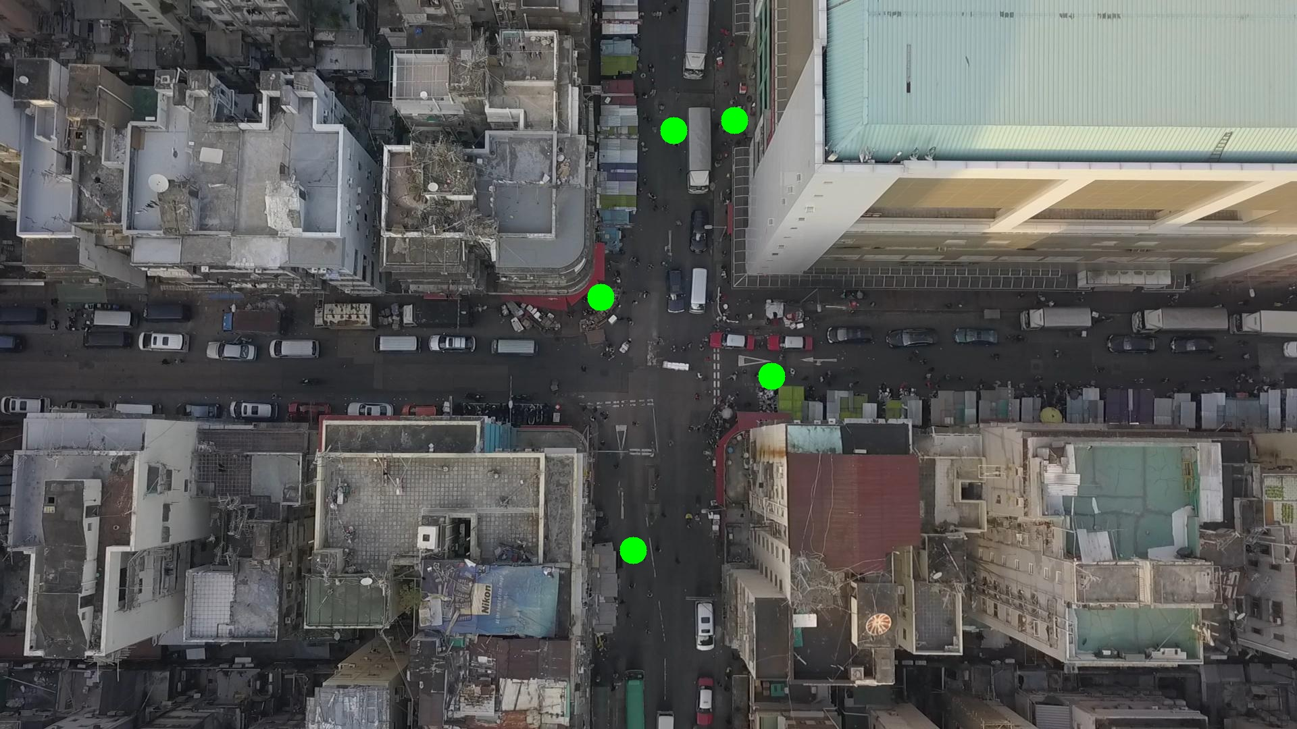

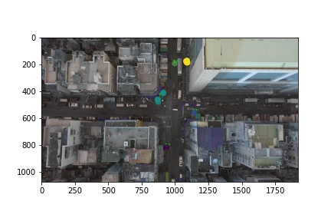

Silhouette metric for img011003.jpg is: 0.9354920416532272

Davies Bouldin metric for img011003.jpg is: 0.11728467563251173

Calinski Harabasz metric for img011003.jpg is: 10412.62128086811

ID 0: (1142, 557)

ID 1: (1087, 178)

ID 2: (997, 193)

ID 3: (894, 432)

ID 4: (937, 815)

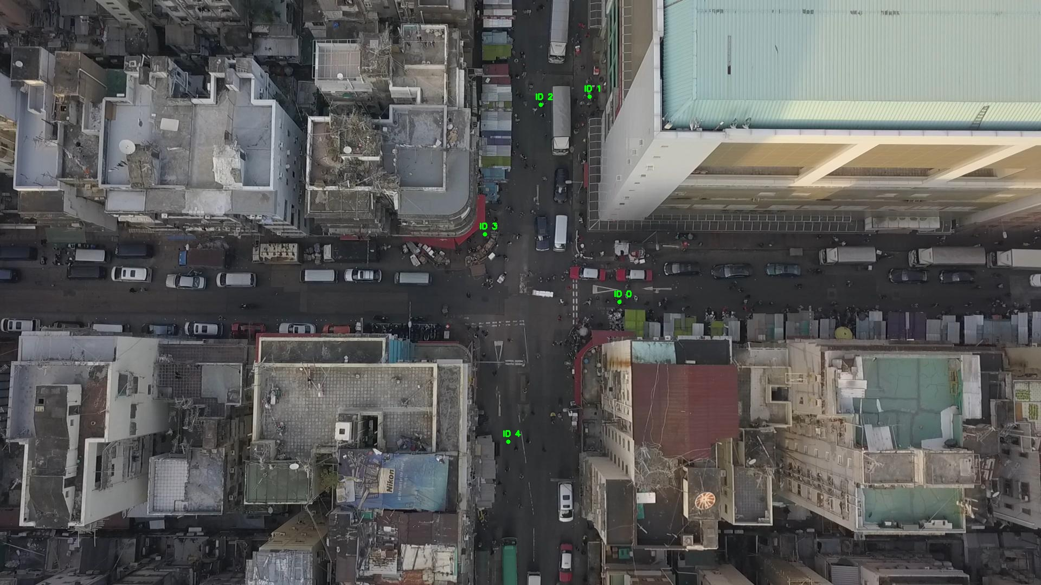

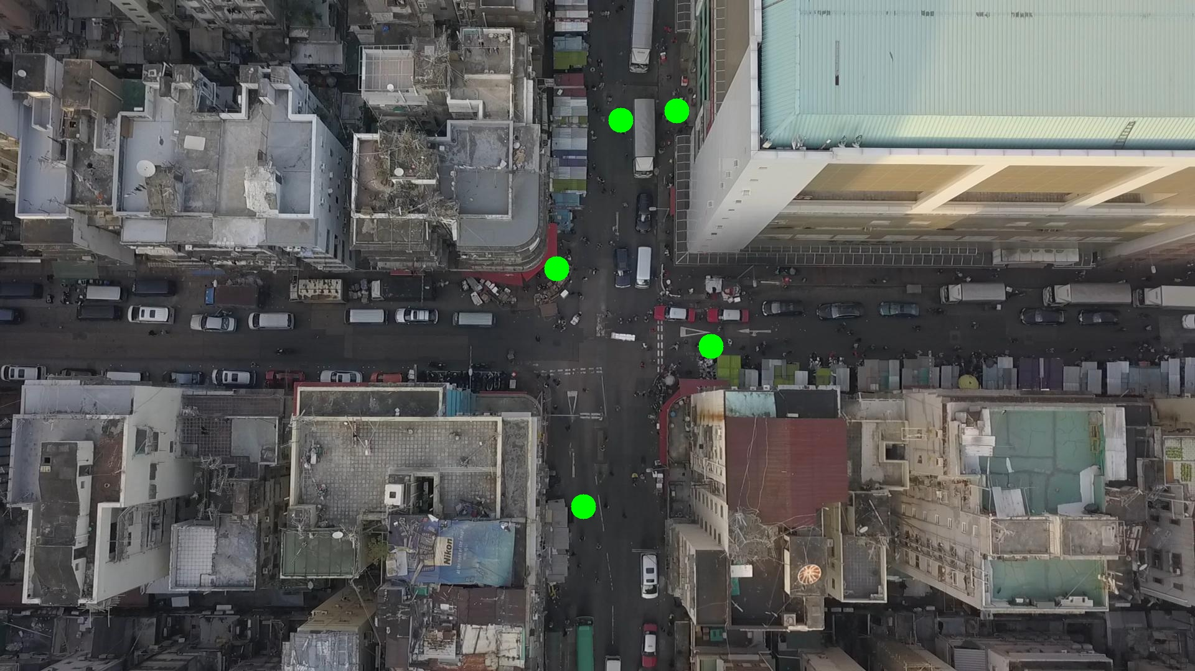

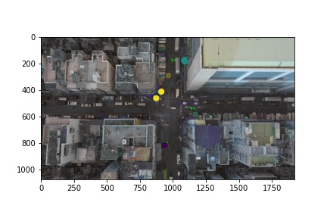

Silhouette metric for img011004.jpg is: 0.881119622029327

Davies Bouldin metric for img011004.jpg is: 0.17155207861661687

Calinski Harabasz metric for img011004.jpg is: 5342.779099694888

ID 0: (1142, 557)

ID 1: (1087, 180)

ID 2: (997, 193)

ID 3: (889, 439)

ID 4: (937, 815)

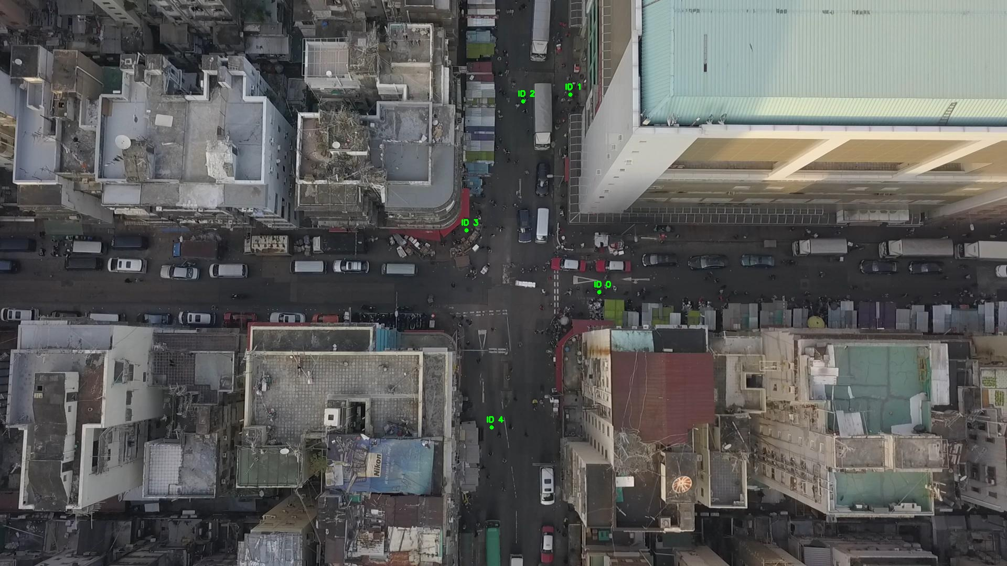

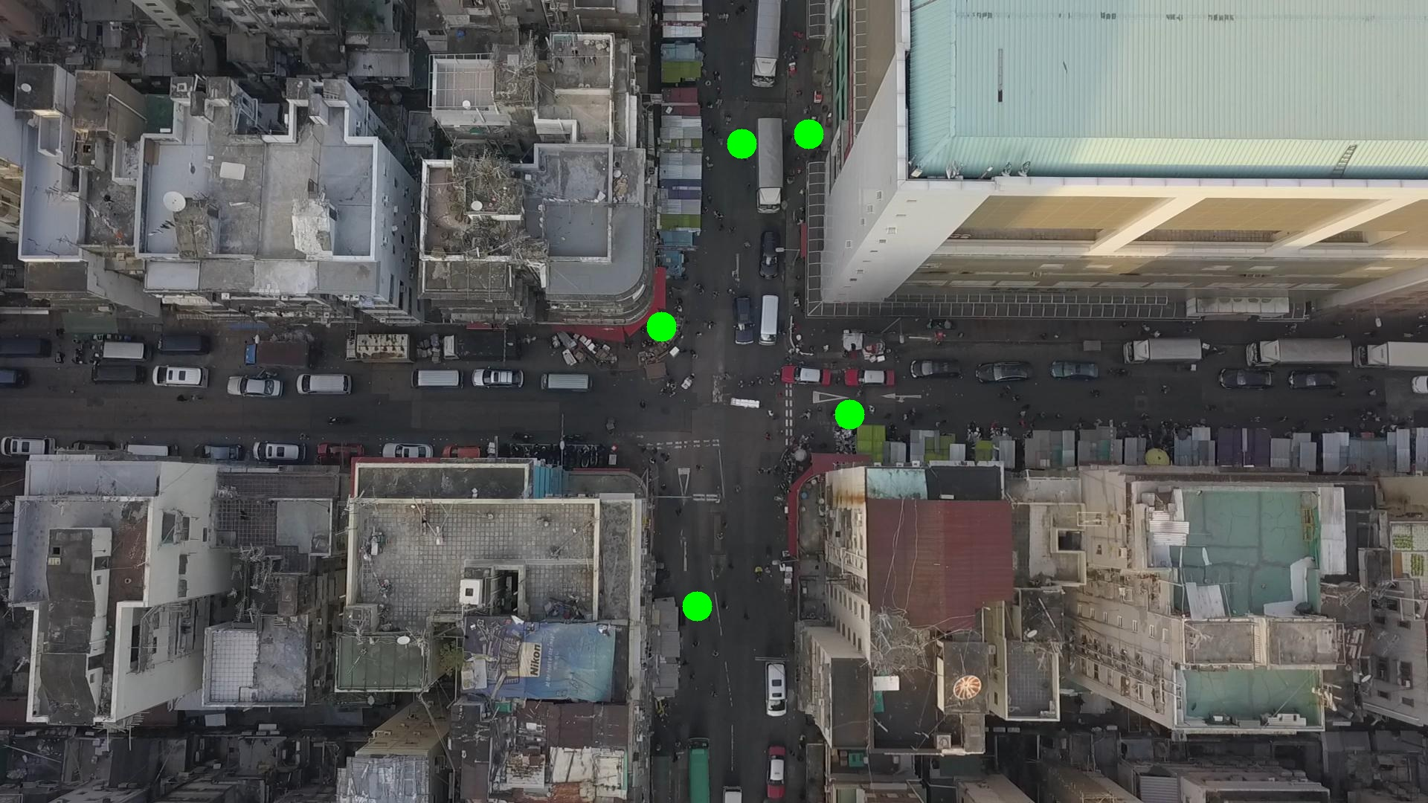

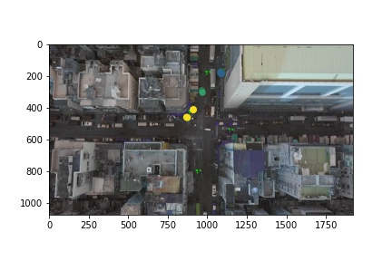

Silhouette metric for img011005.jpg is: 0.776845368069673

Davies Bouldin metric for img011005.jpg is: 0.20892667860871847

Calinski Harabasz metric for img011005.jpg is: 16042.61248349653

ID 0: (1112, 575)

ID 1: (1059, 184)

ID 2: (997, 193)

ID 3: (916, 399)

ID 4: (937, 813)

ID 5: (96, 478)

ID 6: (1376, 554)

ID 7: (891, 654)

ID 8: (967, 293)

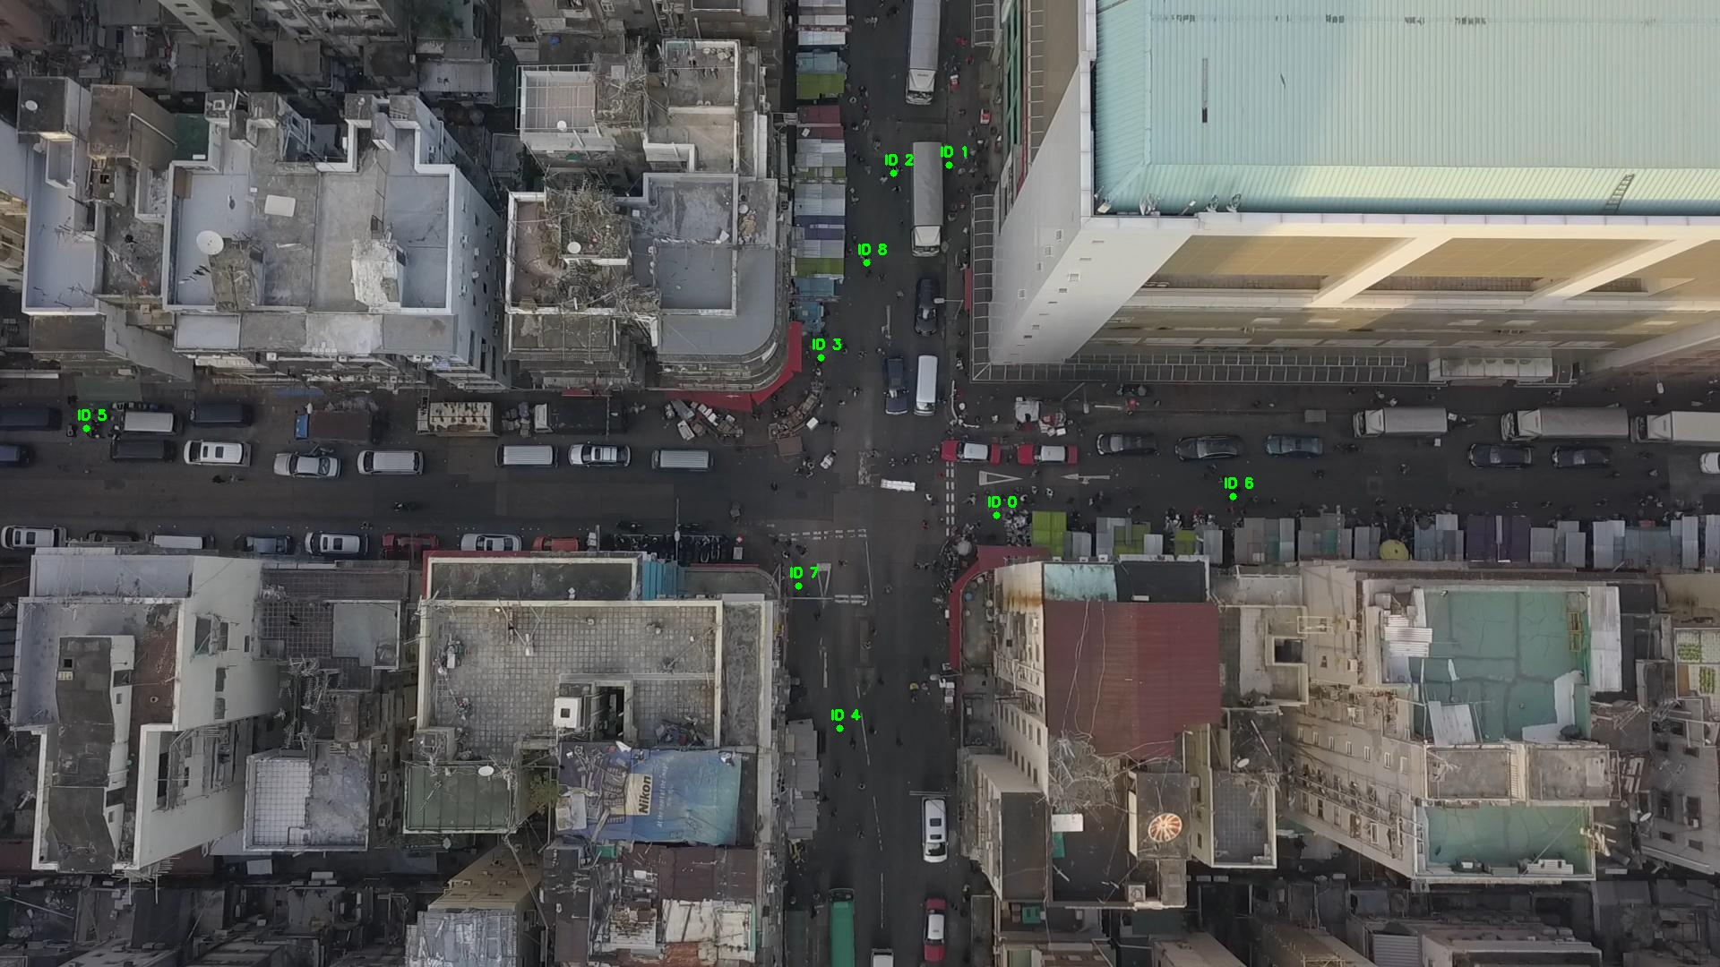

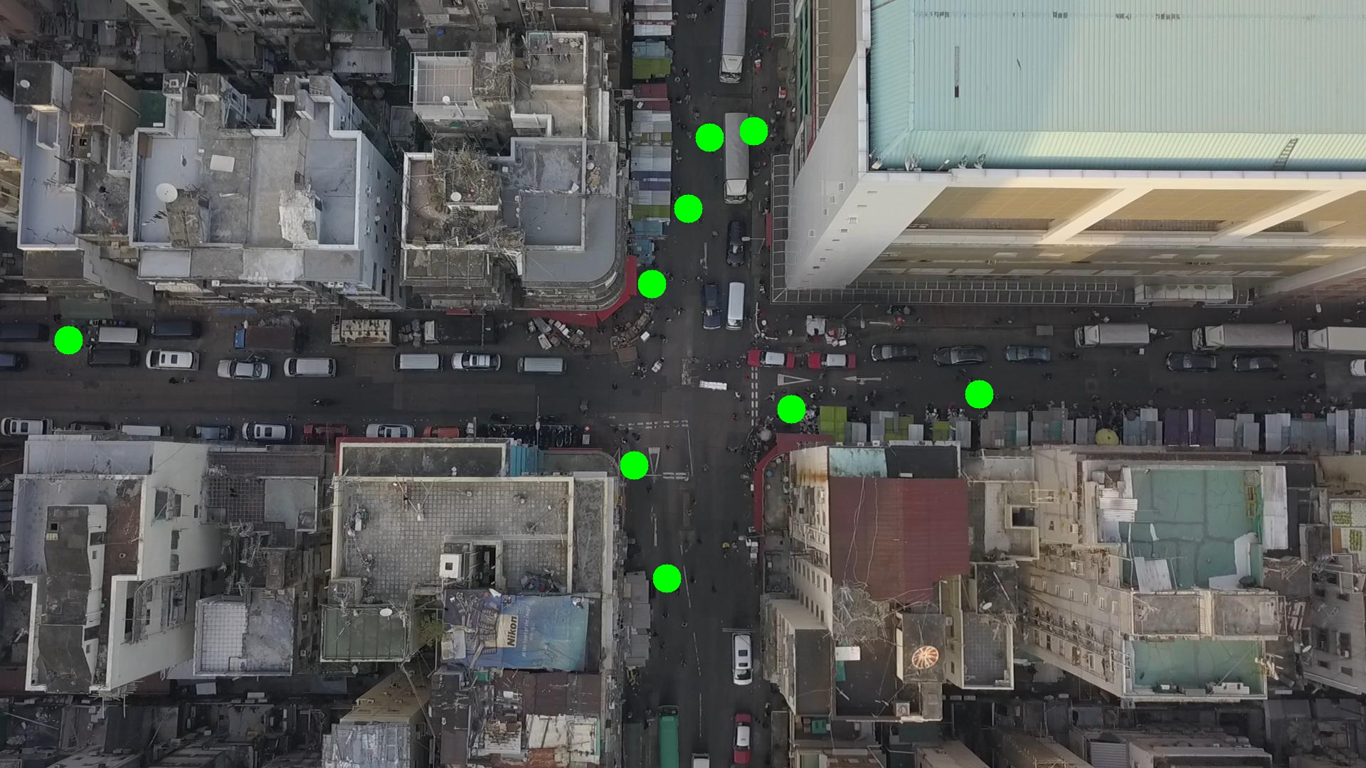

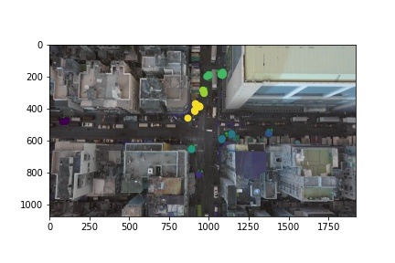

Silhouette metric for img011006.jpg is: 0.7493250743672956

Davies Bouldin metric for img011006.jpg is: 0.22857504744230323

Calinski Harabasz metric for img011006.jpg is: 32528.879579146454

ID 0: (1128, 577)

ID 1: (1039, 188)

ID 2: (997, 193)

ID 3: (904, 418)

ID 4: (937, 811)

ID 5: (97, 477)

ID 6: (1366, 544)

ID 7: (891, 654)

ID 8: (967, 292)

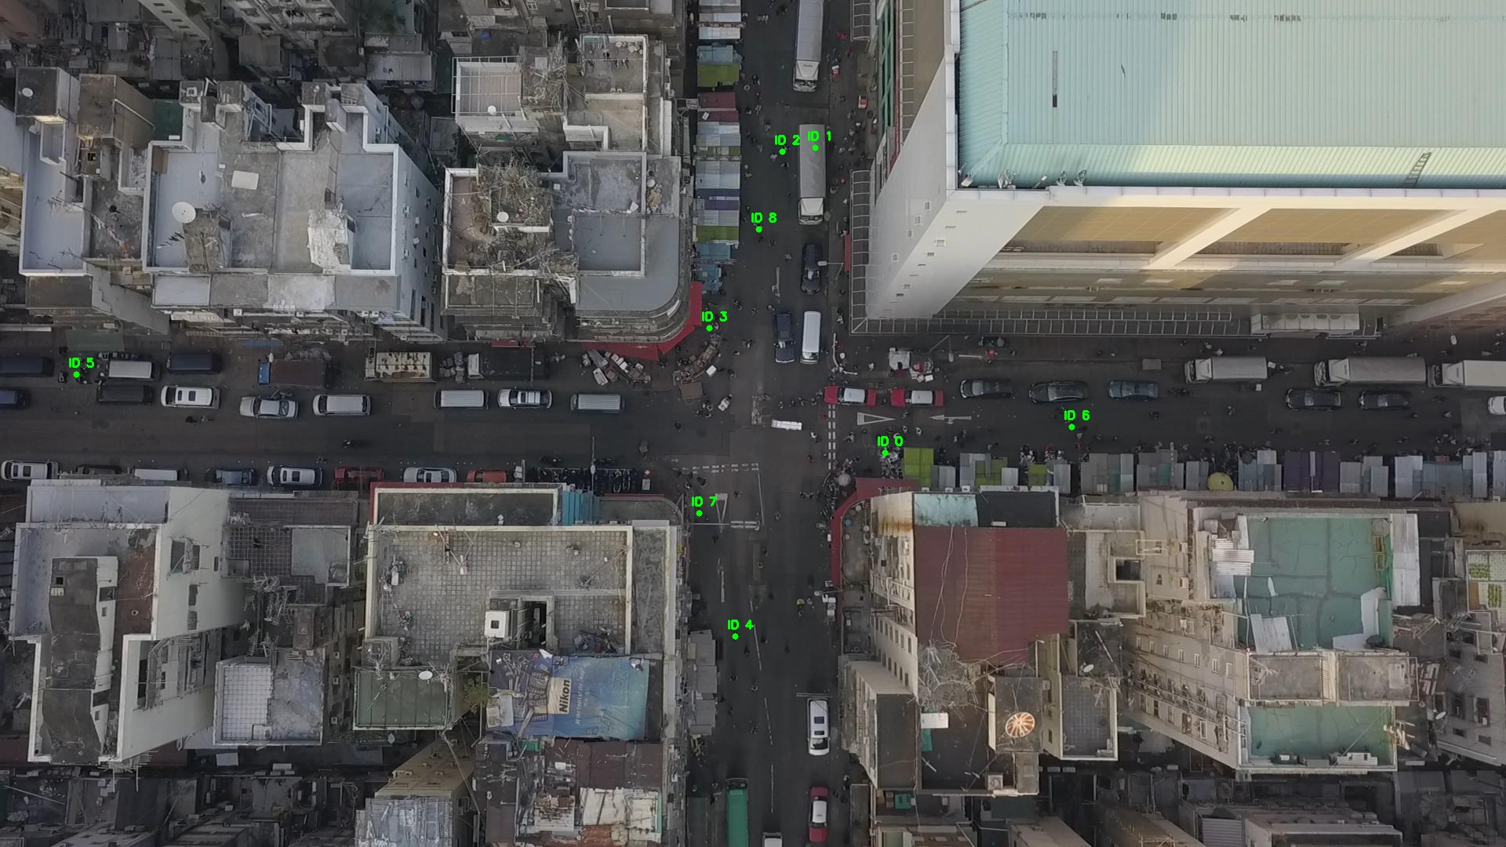

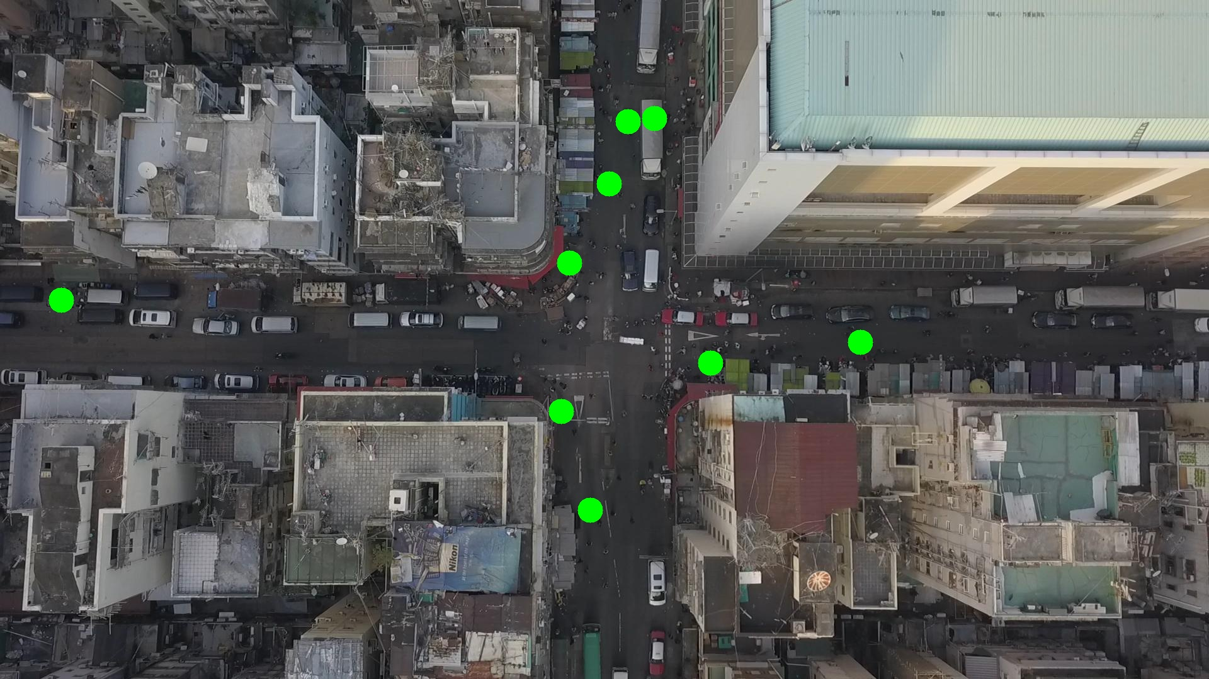

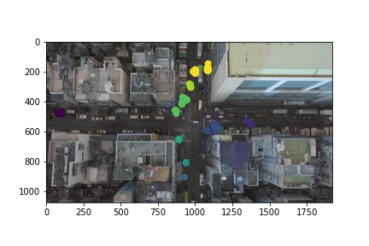

Silhouette metric for img011007.jpg is: 0.8395716203356276

Davies Bouldin metric for img011007.jpg is: 0.23354841668212203

Calinski Harabasz metric for img011007.jpg is: 73943.57775329506

ID 0: (1118, 579)

ID 1: (1039, 188)

ID 2: (997, 197)

ID 3: (922, 389)

ID 4: (937, 811)

ID 5: (92, 477)

ID 6: (1377, 553)

ID 7: (891, 654)

ID 8: (967, 291)

ID 9: (930, 906)

ID 10: (890, 494)

ID 11: (1083, 177)

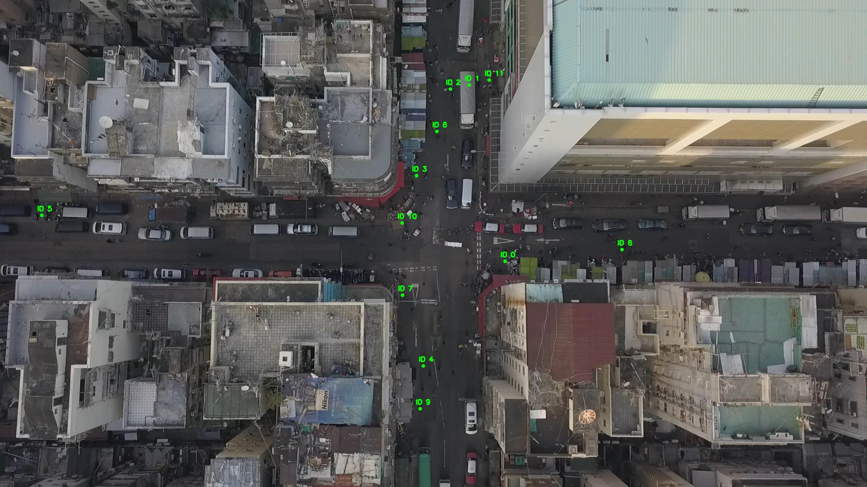

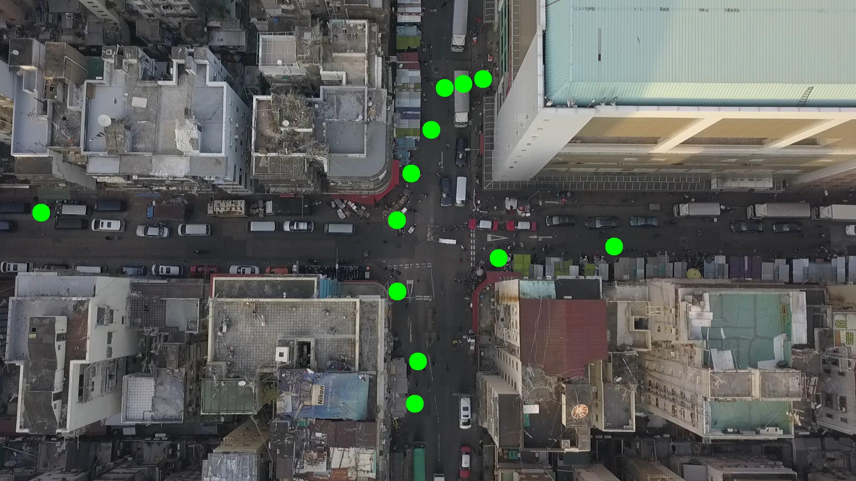

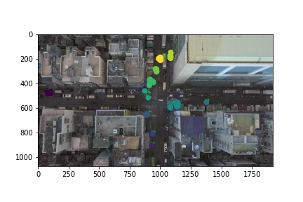

Silhouette metric for img011008.jpg is: 0.7939978408749114

Davies Bouldin metric for img011008.jpg is: 0.19711104980119787

Calinski Harabasz metric for img011008.jpg is: 42171.77607178396

ID 0: (1121, 578)

ID 1: (1039, 188)

ID 2: (997, 197)

ID 3: (921, 388)

ID 4: (937, 811)

ID 5: (89, 478)

ID 6: (1149, 467)

ID 7: (891, 653)

ID 8: (967, 291)

ID 9: (930, 904)

ID 10: (899, 518)

ID 11: (1067, 184)

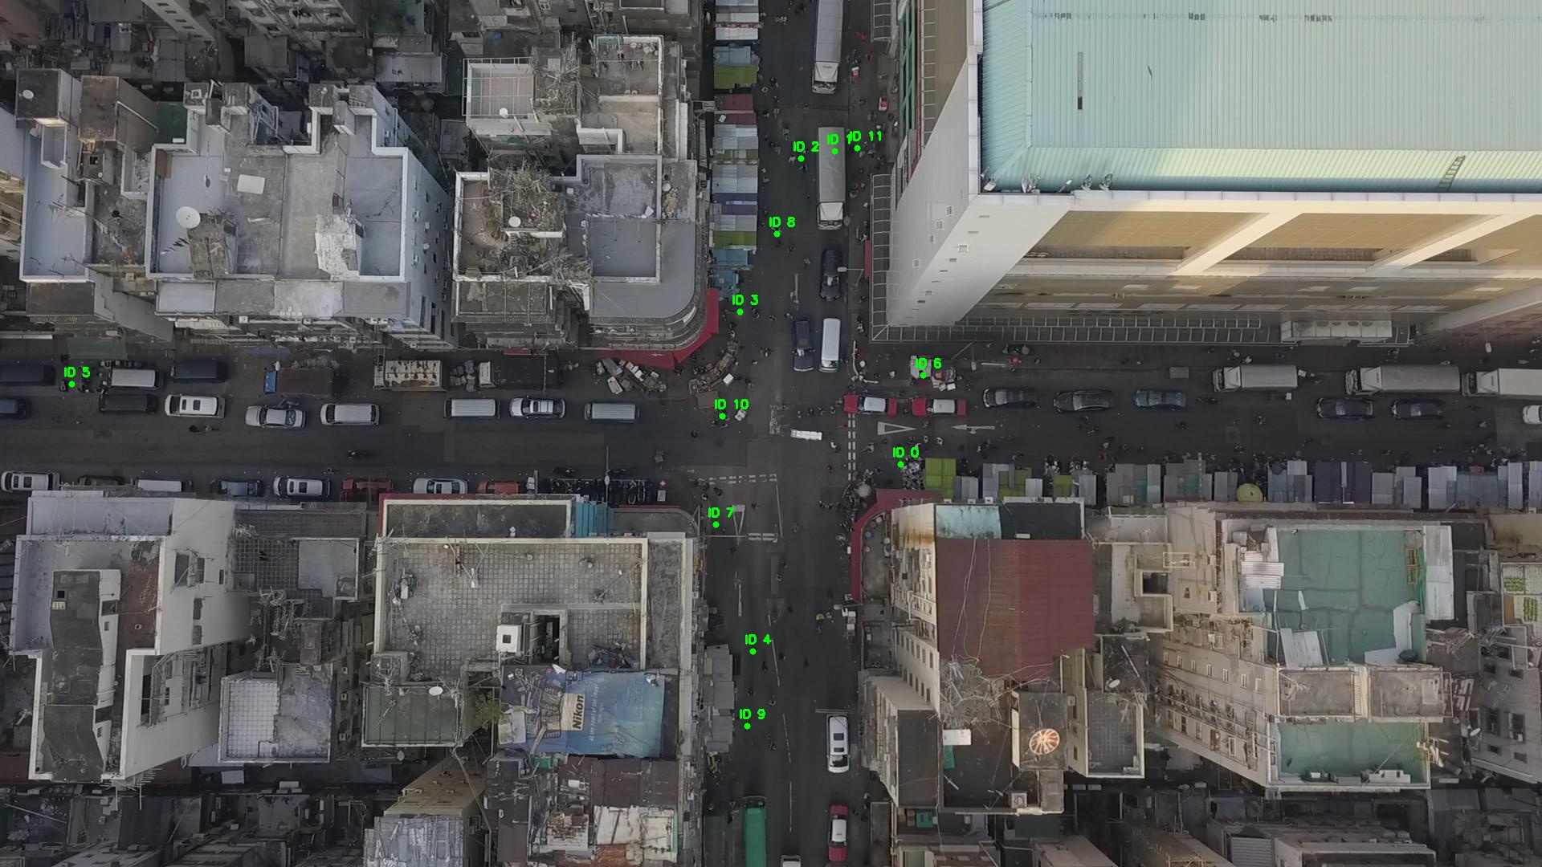

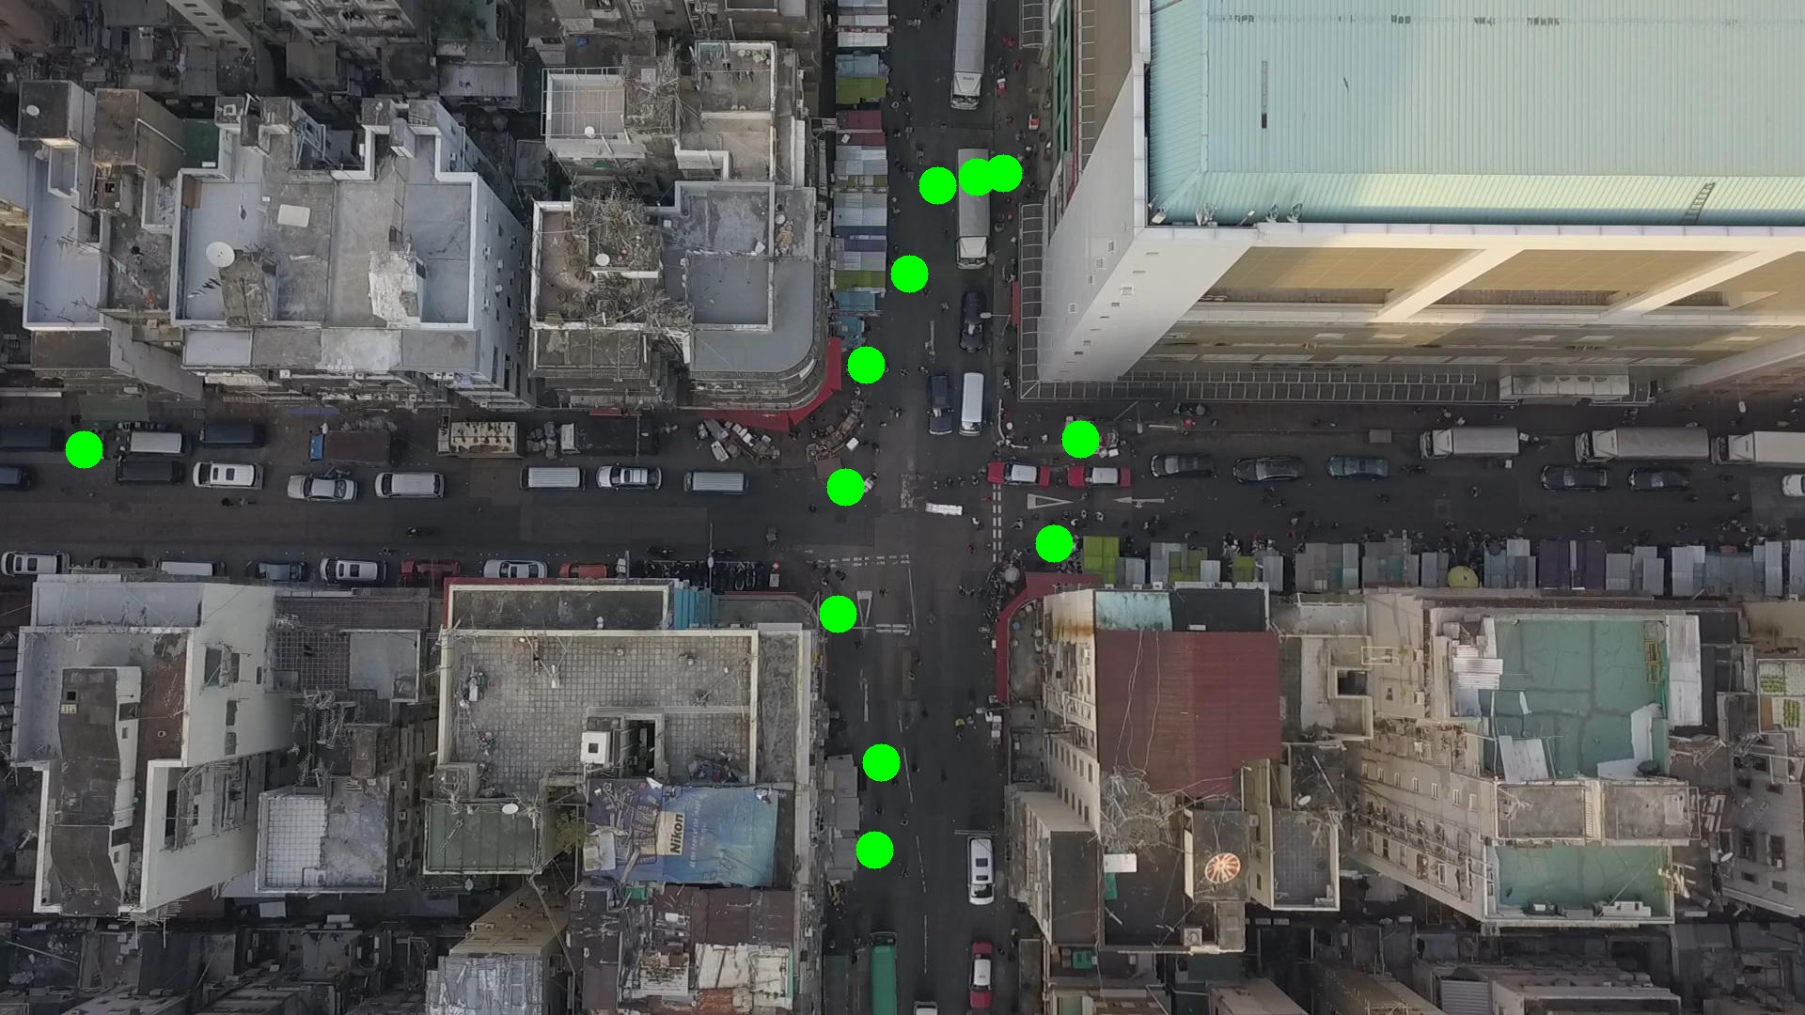

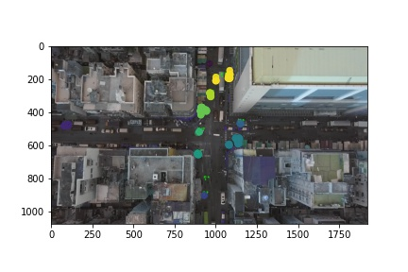

Silhouette metric for img011009.jpg is: 0.8242408723190844

Davies Bouldin metric for img011009.jpg is: 0.20340804405080296

Calinski Harabasz metric for img011009.jpg is: 62566.57210702178

ID 0: (1130, 581)

ID 1: (1051, 188)

ID 2: (997, 197)

ID 3: (919, 389)

ID 4: (937, 811)

ID 5: (96, 476)

ID 6: (1149, 467)

ID 7: (891, 653)

ID 8: (964, 288)

ID 9: (1065, 1012)

ID 10: (892, 525)

ID 11: (1067, 184)

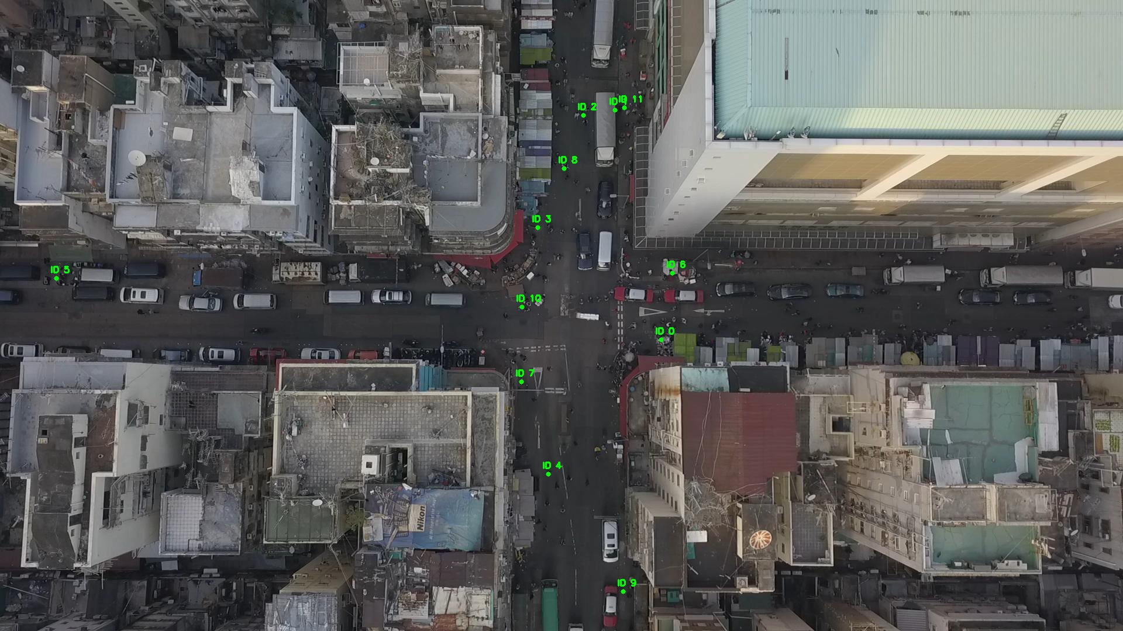

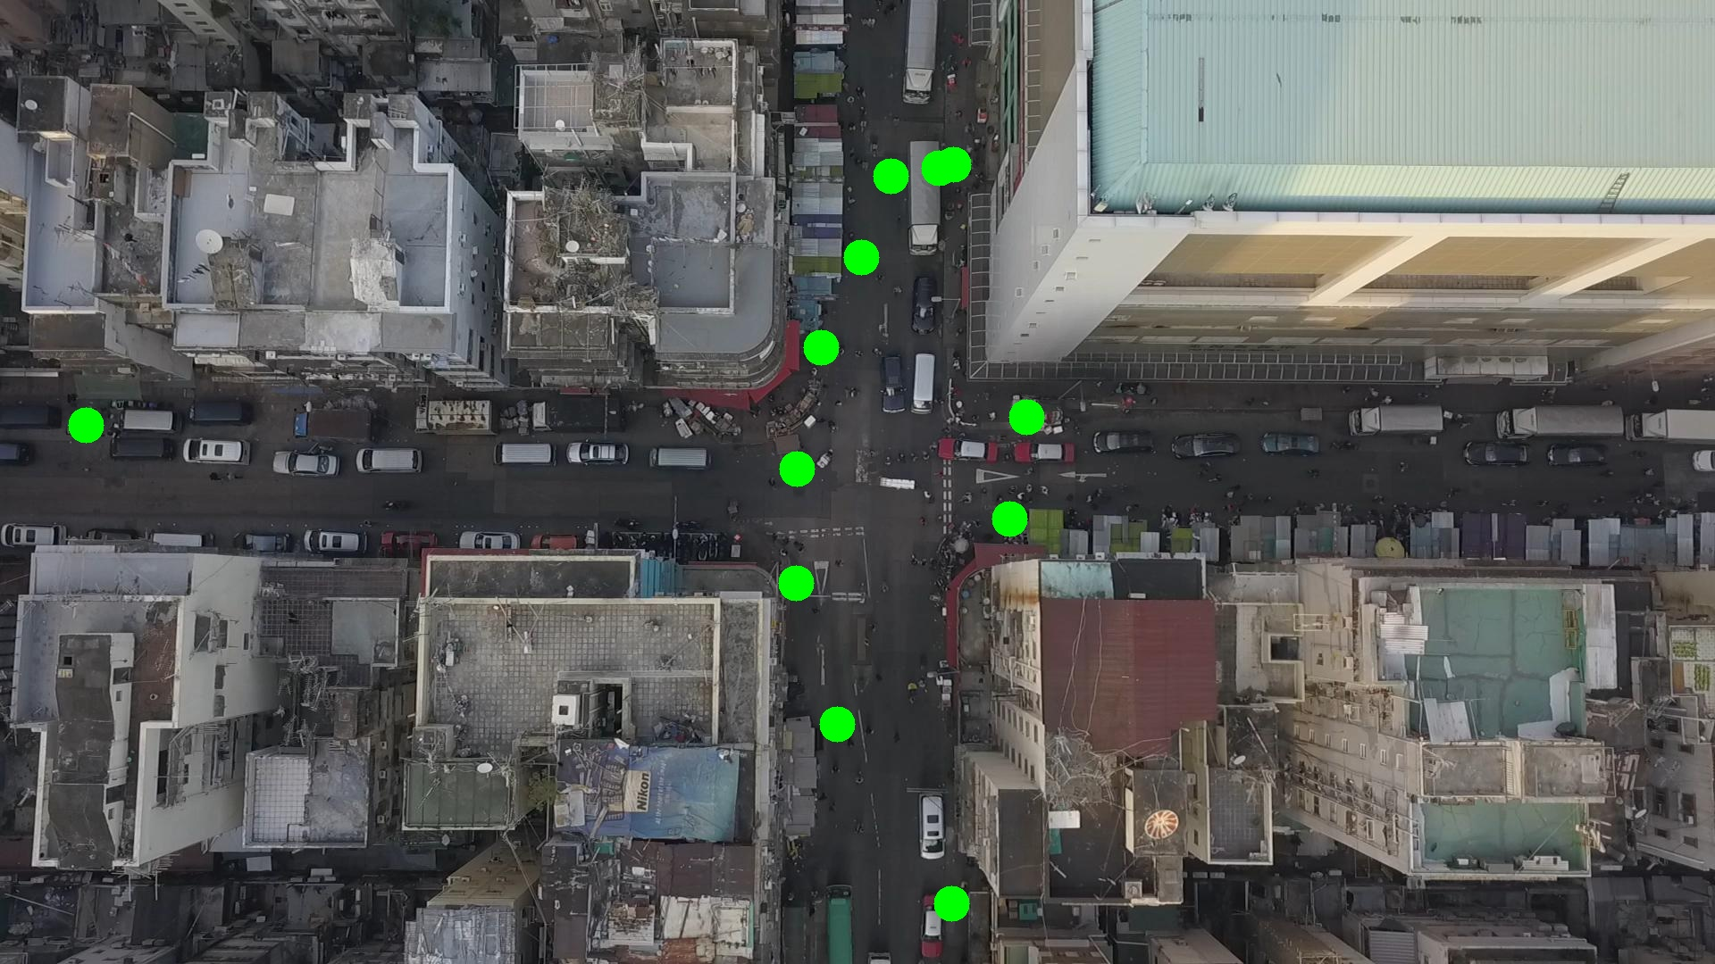

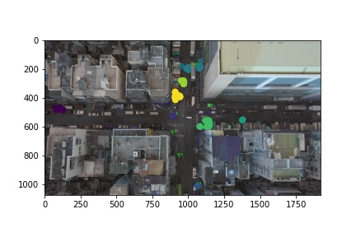

Silhouette metric for img011010.jpg is: 0.8171279401309474

Davies Bouldin metric for img011010.jpg is: 0.19133694835615989

Calinski Harabasz metric for img011010.jpg is: 36598.06500473133

ID 0: (1127, 582)

ID 1: (1049, 182)

ID 2: (997, 197)

ID 3: (920, 394)

ID 4: (937, 811)

ID 5: (86, 478)

ID 6: (1149, 467)

ID 7: (892, 652)

ID 8: (967, 290)

ID 9: (1073, 1012)

ID 10: (894, 526)

ID 11: (1067, 184)

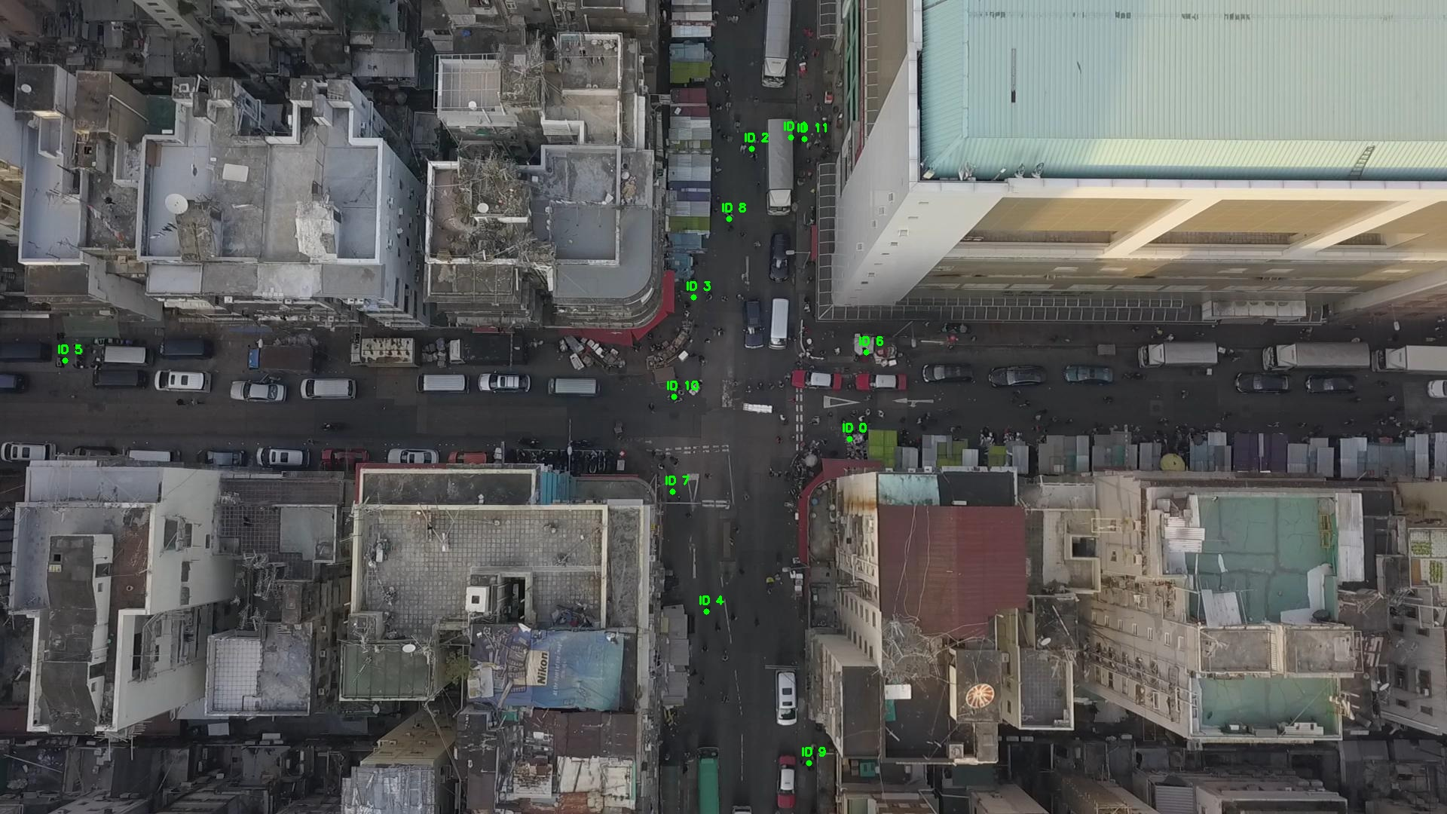

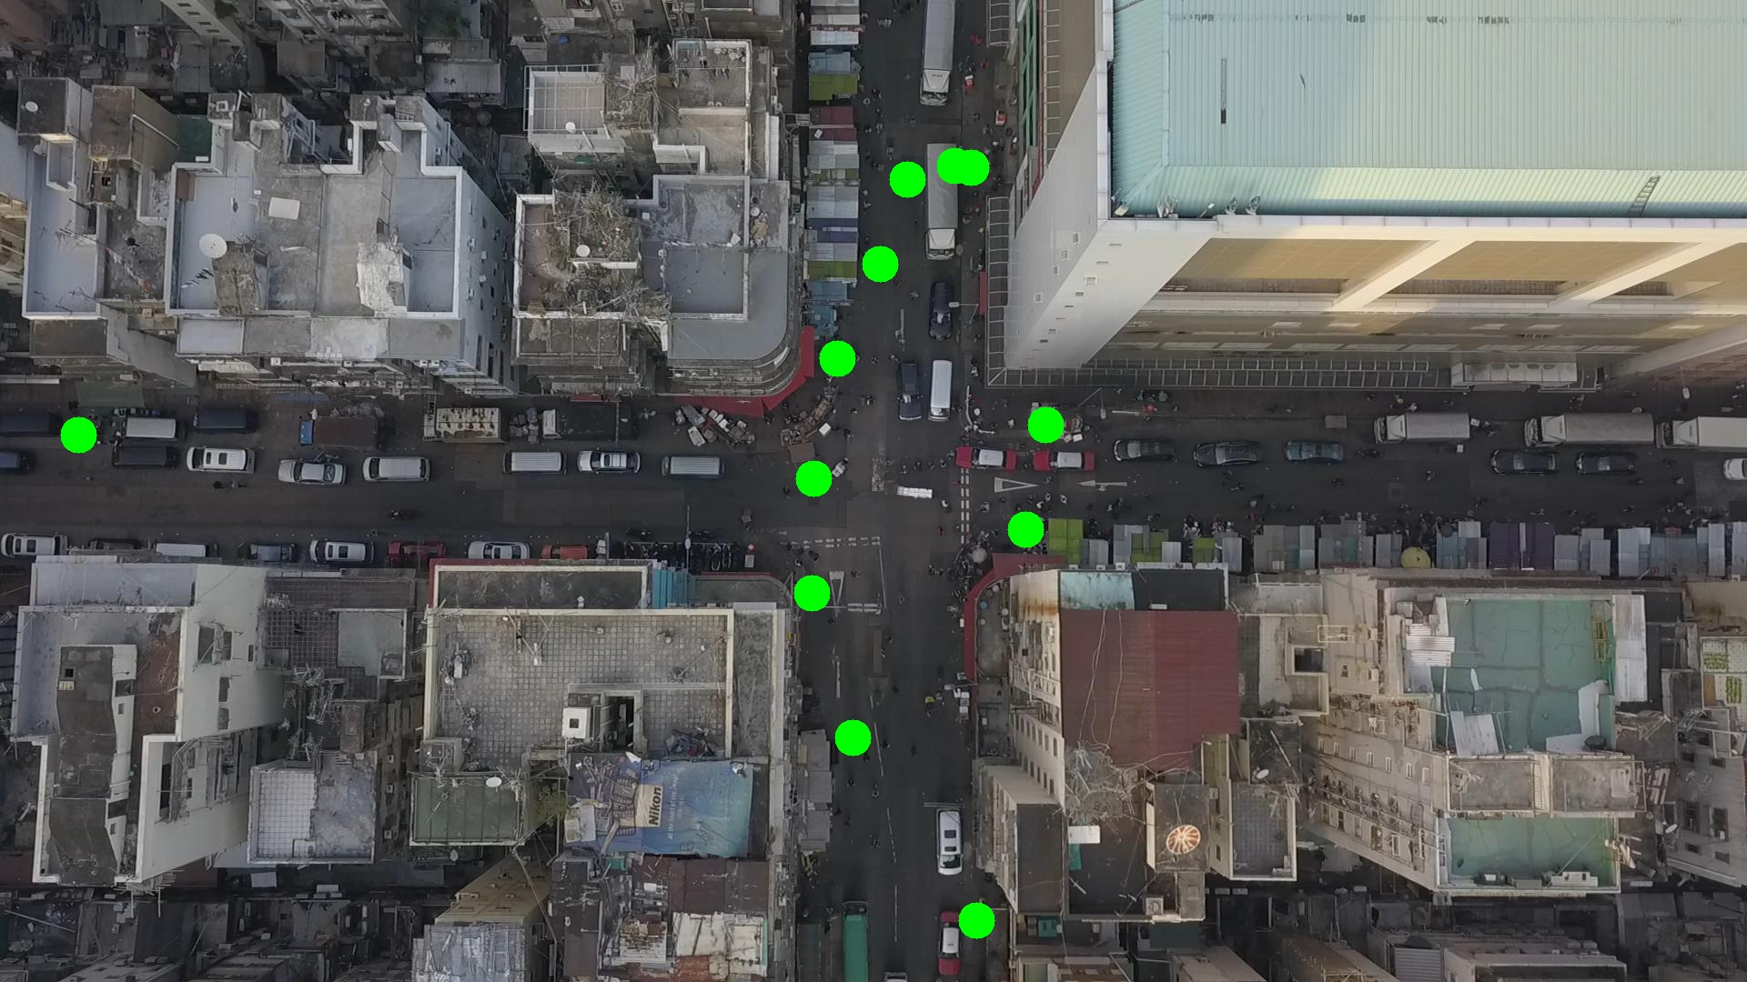

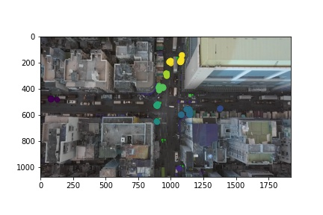

Silhouette metric for img011011.jpg is: 0.8208643553502799

Davies Bouldin metric for img011011.jpg is: 0.1568377571727516

Calinski Harabasz metric for img011011.jpg is: 39186.48939955871

ID 0: (1130, 580)

ID 1: (1056, 181)

ID 2: (997, 197)

ID 3: (917, 389)

ID 4: (949, 830)

ID 5: (87, 479)

ID 6: (1149, 467)

ID 7: (891, 650)

ID 8: (964, 288)

ID 9: (1066, 1012)

ID 10: (894, 527)

ID 11: (1067, 184)

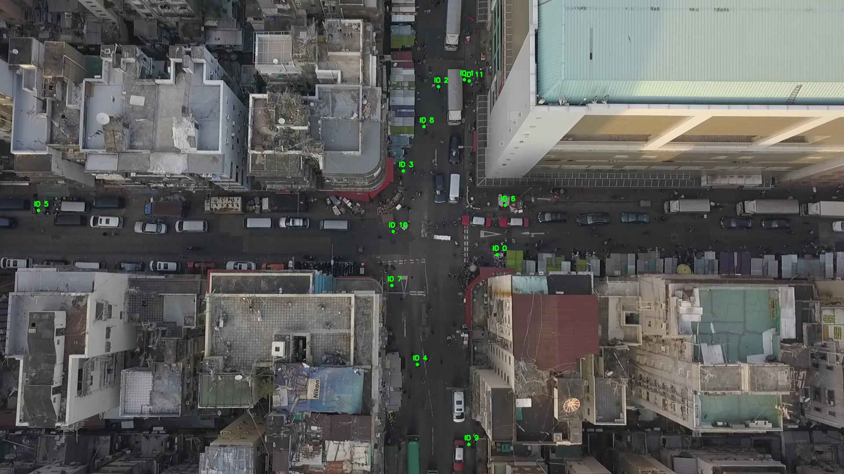

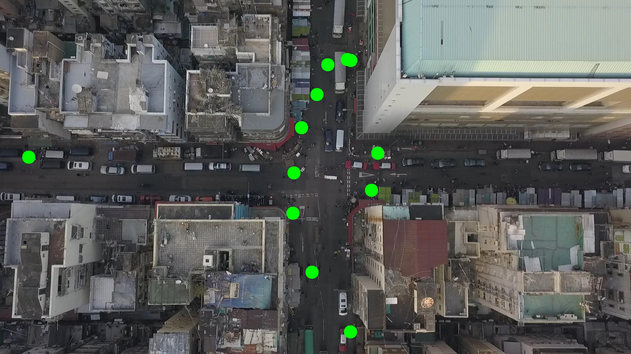

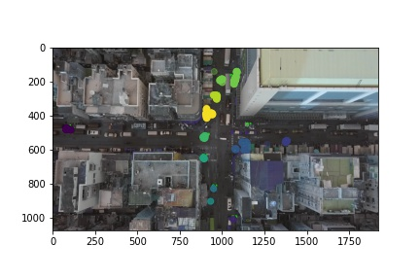

Silhouette metric for img011012.jpg is: 0.8104916272416713

Davies Bouldin metric for img011012.jpg is: 0.17770599887997657

Calinski Harabasz metric for img011012.jpg is: 34993.14309214736

ID 0: (1128, 582)

ID 1: (1052, 181)

ID 2: (997, 197)

ID 3: (924, 391)

ID 4: (949, 830)

ID 5: (83, 479)

ID 6: (1149, 467)

ID 7: (890, 650)

ID 8: (965, 284)

ID 9: (1065, 1011)

ID 10: (889, 526)

ID 11: (1067, 184)

